Student’s name | …………………………………………………….…… | Grade | 6
Subject | Computer | Week No. | 6
Lesson Title | Platformer Game | Unit
Worksheet No. ( 6 )
Question A: write the correct name of each part.

Types of video games (P146)
Y Decrease up | X Increase right
X Decrease left | Y Increase down
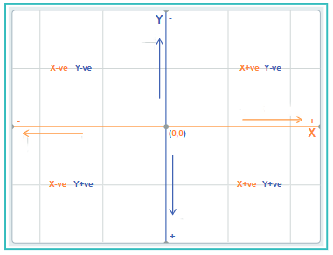
Good Luck

